**DML COMMANDS**

SQL > create table employee_exp5_csa_35(Emp_id int primary key, Emp_name varchar(20),

Dept varchar(20), Salary float);

table EMPLOYEE_EXP5_CSA_35 created.

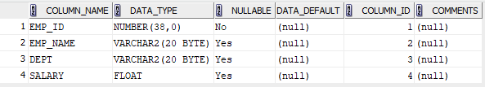

SQL > insert into employee_exp5_csa_35 values(1, 'David Smith', 'HR', 5000.00);

insert into employee_exp5_csa_35 values(2, 'Doney Siby', 'HR', 5000.00);

insert into employee_exp5_csa_35 values(3, 'Charles Brown', 'Sales', 6000.00);

insert into employee_exp5_csa_35 values(4, 'Allen Nolan', 'Production', 9000.00);

insert into employee_exp5_csa_35 values(5, 'Olivia', 'Marketing', 7500.00);

5 rows inserted.

SQL> select * from employee_exp5_csa_35;

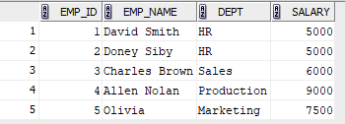

**1)**

SQL> select * from employee_exp5_csa_35 where salary > 7000;

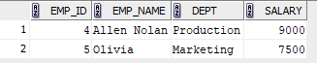

**2)**

SQL> update employee_exp5_csa_35 set salary = 8200.00 where Emp_name = 'David Smith';

1 rows updated.

SQL> select * from employee_exp5_csa_35 where emp_name = 'David Smith';



**3)**

SQL> insert into employee_exp5_csa_35 values(6, 'Daniel Harris', 'Production', 6700.00);

1 rows inserted.

SQL> select * from employee_exp5_csa_35;

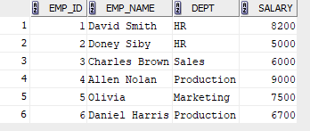

**4)**

SQL> delete from employee_exp5_csa_35 where Emp_id = 3;

1 rows deleted.

SQL>select * from employee_exp5_csa_35

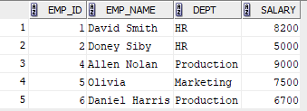

**5)**

SQL> select * from employee_exp5_csa_35 where Emp_name not like 'D%' and

Emp_name not like 'O%';



**6)**

SQL> select Dept,sum(salary) as Total_Salary_Expense from employee_exp5_csa_35

group by Dept;

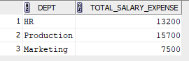

**7)**

SQL> update employee_exp5_csa_35 set Salary = Salary * 1.05 where Dept = 'Production';

2 rows updated.

SQL> select * from employee_exp5_csa_35;

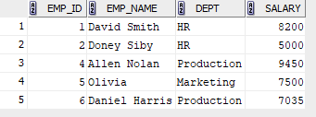

**8)**

SQL> delete from employee_exp5_csa_35 where Salary < 7000;

1 rows deleted.

SQL> select * from employee_exp5_csa_35;

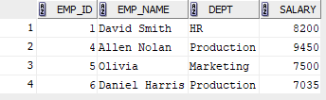

**9)**

SQL> select Emp_name, Salary from employee_exp5_csa_35 where Salary = (select min(salary)

from employee_exp5_csa_35);



**10)**

SQL> update employee_exp5_csa_35 set Salary = 8200.00 where Dept = 'Marketing';

1 rows updated.

SQL> select * from employee_exp5_csa_35;

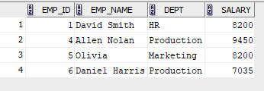

**11)**

SQL> select Emp_name from employee_exp5_csa_35 where Emp_name like 'A%';



**12)**

SQL> select Emp_name from employee_exp5_csa_35 where Emp_name like '%it%';



**13)**

SQL> select distinct(upper(dept)) from employee_exp5_csa_35;

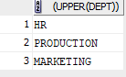

**14)**

SQL> select * from employee_exp5_csa_35 where Dept like 'M_r%' and Dept like '%ket%';



**15)**

SQL> select distinct reverse((upper(dept))) from employee_exp5_csa_35;

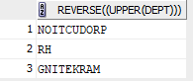

SQL> commit;

committed.